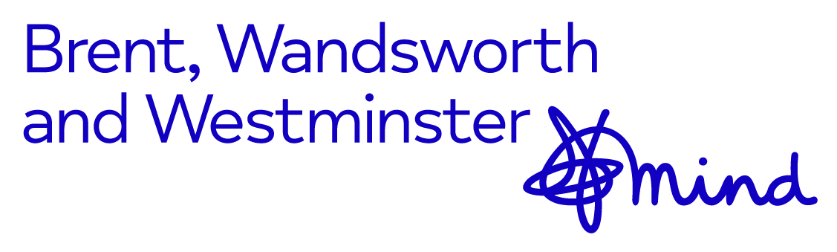

Brent, Wandsworth & Westminster Mind Referral Form
Suicide Bereavement Liaison Service North and South West London

- If you need support in completing this form, ask your GP to help or contact us at sbls@bwwmind.org.uk

Date of Application/Referral
Day | Month | Year

Referrer’s Details
First Name(s) | Last Name | Position/Role
Address (line 1)
Address (line 2)
Town
Postcode
Phone
Mobile
Email

Applicant/Referral Details
First Name(s) | Last Name | AKA (if applicable)
Address (line 1)
Address (line 2)
Town
Postcode
Phone
Mobile
Email

Other information. (Applicant’s date of birth)
Date of Birth | Age

GP Name and Address, NHS Number of Referred
Name of GP | Address & Contact Details
NHS No. (if known)

What borough does the Referred/Deceased live in?
 | Referred | Deceased
Brent
Ealing
Hammersmith & Fulham
Harrow
Hillingdon
Hounslow
Kensington & Chelsea
Westminster
Croydon
Sutton
Merton
Kingston
Richmond
Wandsworth
Other

What services would help support you?
Would you be interested in a group support | Please tick
Yes
No

Name of Deceased
Date of Death
Relationship to the deceased
Method

Accessibility
Access
Is your/the applicant’s first language English?
If not English, is translation/interpreting required?
Do you/does the applicant have a disability?

Declaration of Applicant
I confirm that the information I have provided is correct. I also consent to my contact information being used by BWW Mind Bereavement Officers to provide support (I am aware that this information can be deleted at any time if requested).

Signed: ……………………………………………..…………………….. Date: ……………………………….

Send this form back to: sbls@bwwmind.org.uk

- MONITORING INFORMATION
To promote and ensure equal opportunities in all aspects of our service delivery we gather information on everyone applying or and using our services. This information will be treated with strictest confidence.

Please tick the boxes which apply to you/applicant.

Gender/  Sex | Male | Female | Are you the same,  gender you were assigned at birth. | Prefer not to say
Please Tick

Sexuality | Bi-sexual | Heterosexual | Gay or Lesbian | Prefer not to say
Please Tick

Ethnicity | Asian- Bangladeshi | Asian-  Indian | Asian-Pakistani | Asian-  Other
Please Tick
 | Black African | Black Caribbean | Black British | Black Other
Please Tick
 | Mixed White & Asian | Mixed White &  Black African | Mixed White  & Black Caribbean | Mixed  Other
Please Tick
 | White British | White European | White Irish | White Other
Please Tick
 | Arabic | North African | Gipsy/Traveller | Chinese
Please Tick
 | Prefer not to say
Please Tick

Religion | Christian | Muslim | Jewish | Hindu
Please Tick

 | Sikh | None | Prefer not to say | Other  (Please State)
Please Tick

If you have any questions regarding the referral form please contact Brent, Wandsworth, and Westminster Mind Suicide Bereavement Liaison Team at: sbls@bwwmind.org.uk

